ARCHITECTURE REVIEW TEMPLATE
Azure Well-Architected Framework | Pre-Launch Multicloud AI Review

Prepared by: [Your Full Name]
Date: [DD Month YYYY]
Organization: National Retail Corp (Scenario)
System under review: Multicloud AI Fraud Detection Platform (Ask Retail / StockSense / HRHelper)
Review scope: Pre-launch WAF assessment ➔ all 5 pillars
Primary cloud: Azure (East US 2)
Disaster Recovery environment: (Amazon Web Services) AWS (us-east-1)
Edge: Selected inference nodes at retail distribution centers

Note: This template is pre-structured to the LC1 project rubric. Purple text = placeholder ➔ replace every instance before submission. Do not delete section headers or table rows; the AI grader evaluates structure as well as content.

1. EXECUTIVE SUMMARY
Guidance: Target length: half a page (~120–150 words).
Write this last. Must state: scope, top 3 risks, single most important immediate action, and one-line cost or schedule implication for that action.

Scope | [One sentence: what system, which environments, why this review matters now]
Top 3 Risks | 1. [Risk name ➔ Pillar ➔ Severity]  2. [Risk name ➔ Pillar ➔ Severity]  3. [Risk name ➔ Pillar ➔ Severity]
Priority Action | [The single most important fix ➔ must match Rank 1 in Section 3 Roadmap]
Cost / Schedule Impact | [for example, "Estimated implementation: 1 week; expected reduction in Reliability outage risk: High. Graphics Processing Unit (A specialized electronic circuit designed to accelerate computation, commonly used for AI inference and machine learning workloads.) scheduling fix estimated to close 40% budget overrun within Q3."]

Guidance: Target length: 2–3 pages total across all five pillars.
One finding minimum per pillar. All findings must cite specific evidence from the Scenario_Data_Package.
Compliance links (Payment Card Industry Data Security Standard / SOC 2) are required for Security and Data Sovereignty findings; this is a financial services deployment.

PILLAR 1: RELIABILITY
Finding  [One specific finding tied to scenario evidence ➔ cite the incident report number, cost figure, or policy gap]  Evidence  [Exact data point from Scenario_Data_Package.zip ➔ for example, "Incident 2 timeline shows single-region stateful service caused 47 min outage on 14 Jun"] | Severity  [High / Medium / Low]  Confidence  [High / Medium / Low ➔ state why] | Impact if Unresolved  [Business + technical consequence in 1–2 sentences]  Diagram Callout #  [for example, Callout 1]
Remediation Idea  [1–2 sentences ➔ specific action, not generic advice. For example, "Enable zone-redundant deployment for the stateful fraud scoring service using Azure availability zones (East US 2 primary, paired West US 2 standby)."] | Effort Band  [Quick win <2d / Moderate 1–2w / Significant >2w] | Success Metric  [Measurable outcome ➔ for example. "Reduce Mean Time to Recovery (or Mean Time to Repair) from >45 min to <5 min within 30 days of fix"]  Compliance Link  [Payment Card Industry Data Security Standard req / SOC 2 control / none]

PILLAR 2: SECURITY
Finding  [One specific finding tied to scenario evidence ➔ cite the incident report number, cost figure, or policy gap]  Evidence  [Exact data point from Scenario_Data_Package.zip ➔ for example, "Incident 2 timeline shows single-region stateful service caused 47 min outage on 14 Jun"] | Severity  [High / Medium / Low]  Confidence  [High / Medium / Low ➔ state why] | Impact if Unresolved  [Business + technical consequence in 1–2 sentences]  Diagram Callout #  [for example, Callout 1]
Remediation Idea  [1–2 sentences ➔ specific action, not generic advice. For example, "Enable zone-redundant deployment for the stateful fraud scoring service using Azure availability zones (East US 2 primary, paired West US 2 standby)."] | Effort Band  [Quick win <2d / Moderate 1–2w / Significant >2w] | Success Metric  [Measurable outcome ➔ for example, "Reduce Mean Time to Recovery (or Mean Time to Repair) from >45 min to <5 min within 30 days of fix"]  Compliance Link  [Payment Card Industry Data Security Standard req / SOC 2 control / none]

PILLAR 3: COST OPTIMIZATION
Finding  [One specific finding tied to scenario evidence ➔ cite the incident report number, cost figure, or policy gap]  Evidence  [Exact data point from Scenario_Data_Package.zip ➔ for example, "Incident 2 timeline shows single-region stateful service caused 47 min outage on 14 Jun"] | Severity  [High / Medium / Low]  Confidence  [High / Medium / Low ➔ state why] | Impact if Unresolved  [Business + technical consequence in 1–2 sentences]  Diagram Callout #  [for example, Callout 1]
Remediation Idea  [1–2 sentences ➔ specific action, not generic advice. For example, "Enable zone-redundant deployment for the stateful fraud scoring service using Azure availability zones (East US 2 primary, paired West US 2 standby)."] | Effort Band  [Quick win <2d / Moderate 1–2w / Significant >2w] | Success Metric  [Measurable outcome ➔ for example, "Reduce Mean Time to Recovery (or Mean Time to Repair) from >45 min to <5 min within 30 days of fix"]  Compliance Link  [Payment Card Industry Data Security Standard req / SOC 2 control / none]

PILLAR 4: OPERATIONAL EXCELLENCE
Finding  [One specific finding tied to scenario evidence ➔ cite the incident report number, cost figure, or policy gap]  Evidence  [Exact data point from Scenario_Data_Package.zip ➔ for example, "Incident 2 timeline shows single-region stateful service caused 47 min outage on 14 Jun"] | Severity  [High / Medium / Low]  Confidence  [High / Medium / Low ➔ state why] | Impact if Unresolved  [Business + technical consequence in 1–2 sentences]  Diagram Callout #  [for example, Callout 1]
Remediation Idea  [1–2 sentences ➔ specific action, not generic advice. For example, "Enable zone-redundant deployment for the stateful fraud scoring service using Azure availability zones (East US 2 primary, paired West US 2 standby)."] | Effort Band  [Quick win <2d / Moderate 1–2w / Significant >2w] | Success Metric  [Measurable outcome ➔ for example, "Reduce Mean Time to Recovery (or Mean Time to Repair) from >45 min to <5 min within 30 days of fix"]  Compliance Link  [Payment Card Industry Data Security Standard req / SOC 2 control / none]

PILLAR 5: PERFORMANCE EFFICIENCY
Finding  [One specific finding tied to scenario evidence ➔ cite the incident report number, cost figure, or policy gap]  Evidence  [Exact data point from Scenario_Data_Package.zip ➔ for example, "Incident 2 timeline shows single-region stateful service caused 47 min outage on 14 Jun"] | Severity  [High / Medium / Low]  Confidence  [High / Medium / Low ➔ state why] | Impact if Unresolved  [Business + technical consequence in 1–2 sentences]  Diagram Callout #  [for example, Callout 1]
Remediation Idea  [1–2 sentences ➔ specific action, not generic advice. For example, "Enable zone-redundant deployment for the stateful fraud scoring service using Azure availability zones (East US 2 primary, paired West US 2 standby)."] | Effort Band  [Quick win <2d / Moderate 1–2w / Significant >2w] | Success Metric  [Measurable outcome ➔ for example, "Reduce Mean Time to Recovery (or Mean Time to Repair) from >45 min to <5 min within 30 days of fix"]  Compliance Link  [Payment Card Industry Data Security Standard req / SOC 2 control / none]
3. PRIORITIZED REMEDIATION ROADMAP ➔ TOP 5 ACTIONS
Guidance: Target length: 1 page. All 5 rows must be traceable to findings in Section 2. Actions must be traceable: a remediation that does not correspond to any WAF finding will not receive credit (per grader instructions). Owner role must be a team role, not a person name: Platform, SecOps, InfraOps, or AppTeam.

Rank | Action | WAF Pillar | Owner Role | Effort | Timeline | Acceptance Criteria
1 | [Specific action ➔ match exact wording from WAF finding] | [Pillar name] | [Platform / SecOps / InfraOps / AppTeam] | [<2d / 1–2w / >2w] | [Date or sprint relative to Q3 launch] | [How team verifies success ➔ 1 sentence]
2 | [Specific action ➔ match exact wording from WAF finding] | [Pillar name] | [Platform / SecOps / InfraOps / AppTeam] | [<2d / 1–2w / >2w] | [Date or sprint relative to Q3 launch] | [How team verifies success ➔ 1 sentence]
3 | [Specific action ➔ match exact wording from WAF finding] | [Pillar name] | [Platform / SecOps / InfraOps / AppTeam] | [<2d / 1–2w / >2w] | [Date or sprint relative to Q3 launch] | [How team verifies success ➔ 1 sentence]
4 | [Specific action ➔ match exact wording from WAF finding] | [Pillar name] | [Platform / SecOps / InfraOps / AppTeam] | [<2d / 1–2w / >2w] | [Date or sprint relative to Q3 launch] | [How team verifies success ➔ 1 sentence]
5 | [Specific action ➔ match exact wording from WAF finding] | [Pillar name] | [Platform / SecOps / InfraOps / AppTeam] | [<2d / 1–2w / >2w] | [Date or sprint relative to Q3 launch] | [How team verifies success ➔ 1 sentence]

Prioritization Rationale: Impact vs. Effort
Guidance: Place each action's rank number in the correct quadrant below. Actions in "High Impact / Low Effort" must appear at Rank 1–2 in the roadmap.

 | LOW EFFORT | HIGH EFFORT
HIGH IMPACT | Do First (Rank 1–2)  High impact, quick to implement ➔ must not be left below Rank 2 | Plan (Rank 3–4)  Worth the effort ➔ schedule for sprint after launch
LOW IMPACT | Consider (Rank 5)  Quick but marginal ➔ only if capacity allows | Defer / Drop  Do not include in top 5

Prioritization narrative (2–3 sentences for Prompt 3): [Write here the rationale for why Rank 1 was chosen over others. Reference business impact, effort, and Q3 launch constraint. This text goes verbatim into the Prompt 3 text box ➔ it must be consistent with the Rank 1 action in the roadmap above.]
4. ANNOTATED ARCHITECTURE DIAGRAM
Guidance:
Target: 1 page. Insert your annotated version of Baseline_Architecture_Diagram.svg here as a PNG or embed the file reference. Callout numbers on the diagram must match the "Diagram Callout #" fields in Section 2. Include the legend below. Export diagram at 300 DPI minimum; text must be legible at A4 / US Letter print size. An example has been shared with you.

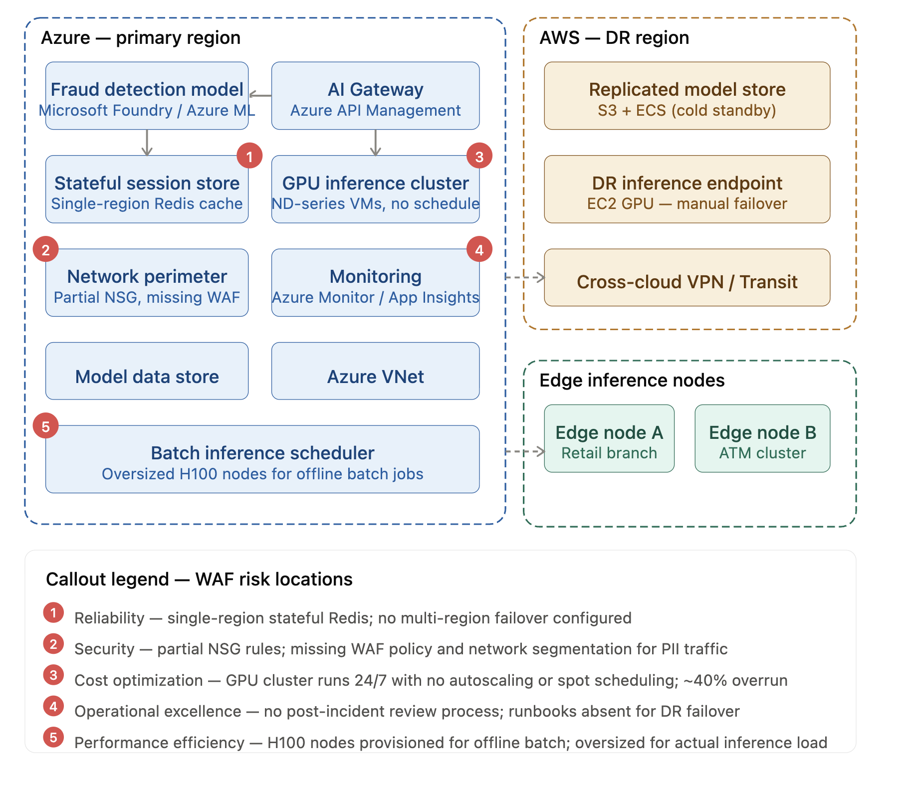
Diagram Legend
Red callout | High severity | Amber callout | Medium severity | Blue callout | Low severity
Quick win | <2 days effort | Moderate | 1–2 weeks effort | Significant | >2 weeks effort

Appendix A: Incident Report Summaries
Incident | Date | Symptom | Suspected Root Cause | WAF Pillar
INC-001 | [Date] | [Brief symptom description] | [Root cause note from report] | [Pillar]
INC-002 | [Date] | [Brief symptom description] | [Root cause note from report] | [Pillar]
INC-003 | [Date] | [Brief symptom description] | [Root cause note from report] | [Pillar]

Appendix B: Graphics Processing Unit (A specialized electronic circuit designed to accelerate computation, commonly used for AI inference and machine learning workloads.) Cost Snapshot
Period | Budget | Actual
[Period from scenario data] | [Budget $] | [Actual $ ➔ ~40% overrun]

Appendix C: Policy / Configuration Status Summary
[Summarise key gaps from policy_config_status in Scenario_Data_Package.zip ➔ for example, missing network segmentation rules, encryption settings not enforced, region restrictions absent. Reference specific policy names where available.]

Template aligned to:
- Azure Well-Architected Framework 2026 (learn.microsoft.com/en-us/azure/well-architected)
- Azure Well-Architected Review assessment (learn.microsoft.com/en-us/assessments/azure-architecture-review) |
- Azure compliance ➔ Payment Card Industry Data Security Standard & SOC 2 Type II (learn.microsoft.com/en-us/azure/compliance).
- Effort bands (Quick win / Moderate / Significant) are course-defined;
- Azure Advisor uses High/Medium/Low impact categories.

